Trip Report of the VT Crop Stage Plots Near Wood River Interchange I-80

To: Michael Dobesh
From: Michael Petersen, Soils Consultant

Mike,
At this point in time for the corn that Tanner is growing the differences are visible when we look closely. The major advantages of adding the fungi mix and AgpHRx come to light when I observed the rooting numbers. In this report I will offer what the numbers tell us with height differences, ear placement and numbers of leaves the plant exposed.
During my field observations I could not get to the bottom of the field due to the ponding effect from the road ditch and on up into the field for about 80 feet. I was not about to wallow around in 15 inches of water and mud.
These two products depict certain differences via the three graphics I have included in this report that by adding them in combination that the very young plants are setting up the potential to achieve more water and nutrients than without either or both which is your control. I know that your grower on the 13th of June (late afternoon) came in with a coulter-Injector tool and inserted nitrogen into the middle of the row area (30 inch row spacing). These young plants may take anywhere from 10 to 20 days to see that N product taken up. That could be problematic especially with rain and irrigation via the pivot moving the mobile Nitrate he added.
Figure 1. Plant height on July 26, 2022. Measurements in centimeters, convert by dividing 2.54 to get inches
of height.
The height of the plants, see Figure 1 (I measured from ground surface to top of last exposed leaf right below the tassle) which was fully exposed and dropping pollen. The plants are at their full height. In the control plots, plant height varied from 62 inches to 78 inches with 71% of the plants I measured less than 70 inches in height.. Variability was significant, I believe this is due to the uneven emergence and the early hail damage. In the AgpHRx plot the variation in height was 82 to 92 inches, with 99% of the plants over 73 inches in height. In the plots where the fungi was added; 77% of the plants are taller than 70 inches. All this data says is that the variability in height and then when we look at ear placement we will see the significance of having a plant population even for harvestability.
.

Figure 2. Ear placement in reference to harvestability

Both CNH and John Deere recommend setting the corn head in the fall to harvest ears 18 to 24 inches above the ground. Reasons offered are, (1) residues/stalks will not blow away into ditches and neighbors fence rows, windbreaks, (2) lesser amounts of corn matter going through the combine allows for better fuel conservation, (3) less impact on the internal parts of the combine so the machine is more efficient, (4) lesser amounts of stalks, leaves, etc. allows for better cleaning of the grain, and (5) higher stalks are the minimizing of tire punctures is a real good thing.
So you can see each one of these plots the ear placement is adequate to facilitate what I just spoke of, however the AgpHRx and fungi plots are taller – allowing for more space to raise and lower the head without the snouts digging into the ground to pick up the ears when they droop in the fall.

Figure 3. This chart displays the total number of leaves on the average and stalk diameter just above the node where the crown roots are exposed. Larger diameter indicates more phloem and xylem conductive tissues to move sugars, nutrients and water up and down and now the furnish the plants ear.

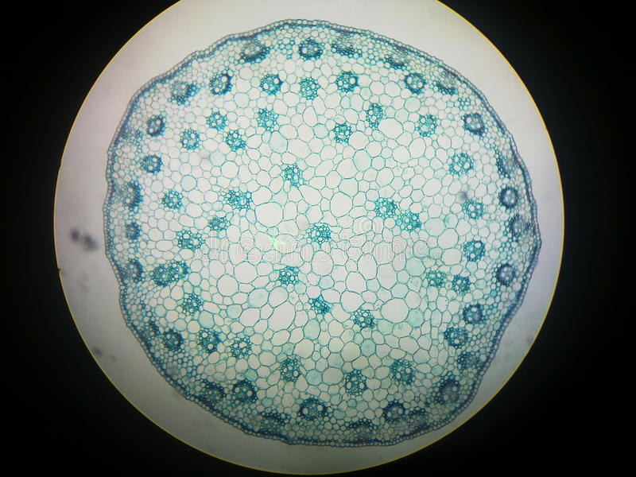
From what I know of today’s hybrids and this particular Fontanelle number it should have grown to expose 15 to 16 leaves. The addition of the fungi provided a 6% improvement in stalk diameter which means more phloem and xylem packets. In the image to the left there is 61 packets which are the dark cluster with open cells that look like two eyes. Those are the xylem tubes which move water from the roots up to the leaves and ear.
The bigger the diameter of the stalk – the more phloem and xylem tissues to move sugars, nutrients. The treatment with the fungi helped facilitate larger diameter stalks. Larger diameter stalks can be a preventative measure to “green snap” also.
I have counted with a blue staining under a microscope in large diameter corn stalks (>32mm) up to 80 Xylem-Phloem packets. With that kind of number, the plant is healthier and usually offers a better yield of kernels.
Without a backhoe to dig out a root profile I did one thing close to what tells the story of below ground and overall health of the plants Michael. Popped out the nodal crown, washed the roots so I could count the five nodes of roots after removing the adventitious roots from node #6.
Table 1. In this table I counted nodes #1 through #5 for five plants in each of the three plots from random locations. The full compliment of nodal roots in modern day corn is a potential of 60 roots. That breaks down as follows: potentially each plant can have: 6 on node #1 which includes the seedling root, 10 on node #2, 10 on node #3, 14 on node #4, and 20 on node #5. Genetically this is in the DNA of each corn seed.
 | Root Counts of all 5 nodes
 | W/fungi area of field
Node # | 1 | 2 | 3 | 4 | 5 | Totals:
 | 6 | 6 | 10 | 10 | 18 | 50
 | 6 | 5 | 7 | 10 | 14 | 42
 | 6 | 7 | 8 | 10 | 12 | 43
 | 5 | 6 | 9 | 10 | 16 | 46
 | 5 | 6 | 7 | 9 | 14 | 41
Averages | 5.6 | 6 | 8.2 | 9.8 | 14.8 | 44.4
range | 5 to 6 | 4 to 6 | 6 to 10 | 9 to 10 | 12 to 18
 | w/o Fungi AgpHRx applied
 | 6 | 7 | 7 | 10 | 14 | 44
 | 5 | 6 | 8 | 12 | 14 | 45
 | 5 | 5 | 7 | 10 | 15 | 42
 | 5 | 7 | 8 | 9 | 12 | 41
 | 6 | 7 | 7 | 9 | 12 | 41
Averages | 5.4 | 6.4 | 7.4 | 10 | 13.4 | 42.6
range | 5 to 6 | 5 to 7 | 7 to 8 | 9 to 12 | 12 to 15
 | Check rows
 | 6 | 6 | 7 | 8 | 10 | 37
 | 5 | 7 | 8 | 8 | 10 | 38
 | 5 | 6 | 9 | 9 | 11 | 40
 | 5 | 5 | 7 | 10 | 9 | 36
 | 5 | 6 | 8 | 8 | 10 | 37
Averages | 5.2 | 6 | 7.8 | 8.6 | 10 | 37.6
range | 5 to 6 | 5 to 7 | 7 to 9 | 8 to 10 | 9 to 11

Allow me to point out that the fungi treatment is providing a spark, an impetus, a biological push to grow more roots. Nodes #1&2 are the early root system that grow 23 to 25 degrees off the horizontal plane of the soil surface and remain somewhat shallow for the first 40-45 days of the corn plants life. Node number 3 starts to erupt roots at that particular point in the plant’s lifespan, then comes along nodes 4 and 5. Roots developing from node #3 angle out no more than 6-8 inches from the stalk center point and then grow vertically downward. These roots [nodes #3,4,5] feed the plant from deeper depths. They are rapid growing roots, they are also the larger diameter roots that dive deep but also send out laterals 0.5 to 6 inches off the trunk roots. When the plant is at its most rapid growth stage at 55 to 80 days after emergence, roots can grow 3 to 4 inches per day downward. Aboveground growth displays this also but not to the tune of 3 to 4 inches per day. A corn plant stops extending roots when the tassles emerge.
In Table 1., the rows with Averages displayed with the blue highlighter and pink numbers that root numbers were stimulated by the addition of Fungi early and AgpHRx. With higher numbers of Nodal roots 4&5 the deeper roots will be, thus having more access to soil moisture, cooler soils and more nutrients.

Figure 4. Data to compose this graphic came from Table 1. These are averages of the 5 plants I washed and counted roots from each plot/trial. The fungi trial from Nodes 3-5 shows the positive effects.

On the next page I left the images from the first dig of the three different treatments of the young root systems. The differences then I am sure have translated to bigger root systems under the fungi this August. With a 18.6% improvement from the check plots to the fungi plots – that is truly significant for the plants with fungi added and should translate into yield improvements. How much, only the combine will tell later this fall.

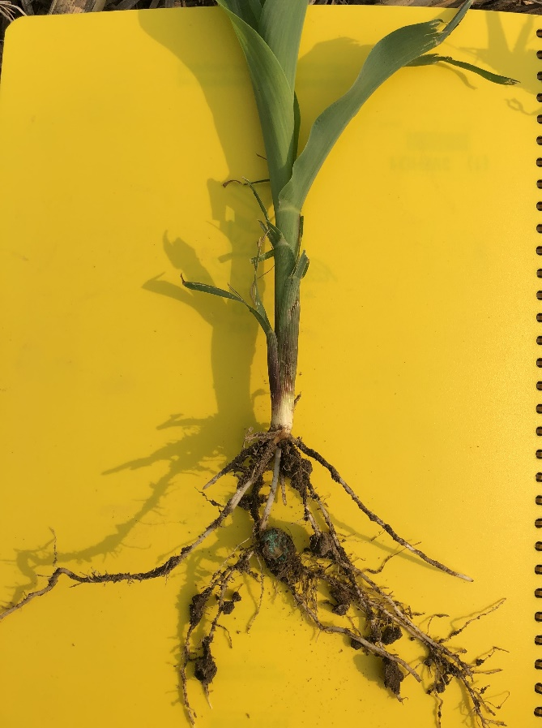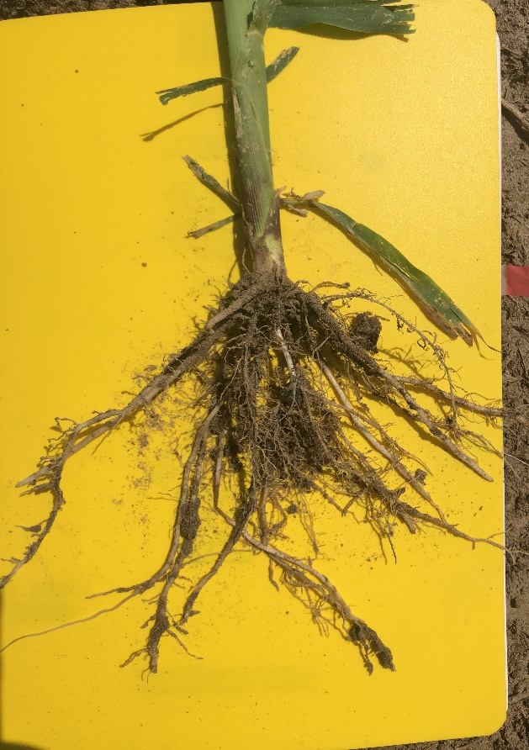
Images 1 & 2 Left image – roots of the AgpHRx added; right image – roots of the AgpHRx + fungi added
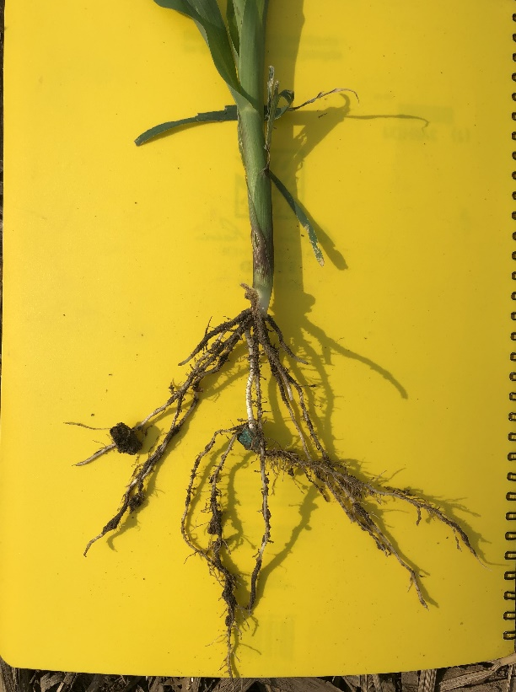
Even early in the life of the corn, mycorrhizae were showing that roots are encouraged and stimulated.
Image 3: Picture of the roots without either product
……………………………………………………………….---------------------------------…………………………………………………………………...

CONCLUDING THOUGHTS:
To bring this to a conclusion; the root systems in the fungi plot definitely has an improved mass of roots. The only way I know to get a full look at the roots would be to bring in a backhoe and excavate, pick the roots, count and measure volume of soil to root length. I am pretty sure your client does not want that during the growing period.
Two years ago near Polk, NE we dug root pits for the Pioneer folks that seed was purchased from to give them a better picture of how well roots did under gravity irrigation and this new hybrid that we grew. The volume of roots in the soil was over 6,000 cubic inches per plant. In a silty clay loam soil that provides right at 6 gallons of water for the mature plant when the soil is near field capacity at tassle and grain fill. That sir is a lot of water and nutrient capacity. Out of that we were pleased to harvest 280 bu/acre grain. In 2021 with the same hybrid we reached the magic mark of 314 bu/acre and applied a competitors mycorrhizal fungi at planting, that is very good corn!!
As we have visited Mike, in a corn-soy rotation using fungi during the corn year is a very smart move. It stimulates the young plant, the fungi extends the root absorption capacity in the upper 12-14 inches of the soil profile. Researchers have claimed that the root system when mycorrhizae have fully infected a corn plants root system that the roots can have up to 400X more absorption capacity in the upper 10-12 inches than untreated plants. Fungi hyphae can extend out from the root nearly four inches, that is phenomenal.
I could go on all day speaking of the great attributes and advantages of fungi but you are aware of many of them already. The plants were not as tall in the fungi + AgpHRx plots compared to the AgpHRx alone, but in the aspects of stalk, number of leaves and root numbers the fungi treated plants excelled. Those attributes of the plant will overshadow the height nearly 9 times out of ten.
The AgpHRx plots does have a positive effect on growth and health of the plants. Without a root pit dug I anticipate the plants will resemble #1 Fungi plants, #2 AgpHRx then #3 the control plots. If I remember correctly the treated with AgpHRx plots in SW Kansas four years ago had a 10 or 12 bu/ac advantage over the untreated. You will know more in 3 months.

Submitted by: Mike Petersen, Soil Scientist Consultant

